Effect of COVID-19 on Global economy, unemployment rate and startup funding

**19bce1009, Arpan Ghosh, Vellore Institute of Technology, Chennai, India**

**19bce1681 Anthra Devarajan, Vellore Institute of Technology, Chennai, India**

## ABSTRACT

Coronavirus disease (COVID-19) is an infectious disease caused by the SARS-CoV-2 virus. The entire world has turned upside down with the recent pandemic of COVID-19. There are a lot of people who died and so many more that fell very sick. With the pandemic, now endemic, there has been a huge loss in the employment field and in the labor force. The economy and livelihoods of a lot of families and countries have turned for the worse. For a lot of people, their businesses have been going through a huge loss. However, for another sect of the society, this endemic has become a boon as the entire online industry has flourished. A lot of people ventured into their own businesses as many lost their jobs and funding for those businesses took place during this period. With this project, we intend to make an analysis of the effect of COVID-19 on the Indian economy and its effect on startup fundings.

## KEYWORD

COVID-19, Start-up Funding, Economy, Unemployment, Start-ups data visualization and analytics

## INTRODUCTION

With the advent of COVID-19 in the year 2019, a lot of things have changed in the world. Lot of people lost their jobs, many companies cut down on the salaries and task force and many more were even being shut down. However, some industries were particularly prospective during this period. Especially with full lockdown imposed in the country, only deliveries seemed feasible. Lot of people had more free time and people purchased a lot of things online. So a lot of industries shifted from an offline, physical platform to a completely online one. The software industry boomed with a huge rise in the demand for softwares that enables video calling, classroom and meeting facilities. The impact of coronavirus pandemic on India has been largely disruptive in terms of economic activity as well as a loss of human lives. Almost all the sectors have been adversely affected as domestic demand and exports sharply plummeted with some notable exceptions where high growth was observed. As per the official data released by the ministry of statistics and program implementation, the Indian economy contracted by 7.3% in the April-June quarter of this fiscal year. This is the worst decline ever observed since the ministry had started compiling GDP stats quarterly in 1996. In 2020, an estimated 10 million migrant workers returned to their native places after the imposition of the lockdown. But what was surprising was the fact that neither the state government nor the central government had any data regarding the migrant workers who lost their jobs and their lives during the lockdown.

The government extended their help to migrant workers who returned to their native places during the second wave of the corona, apart from just setting up a digital-centralized database system. The second wave of Covid-19 has brutally exposed and worsened existing vulnerabilities in the Indian economy. India’s $2.9 trillion economy remains shuttered during the lockdown period, except for some essential services and activities. As shops, eateries, factories, transport services, business establishments were shuttered, the lockdown had a devastating impact on slowing down the economy. The informal sectors of the economy have been worst hit by the global epidemic. India’s GDP contraction during April-June could well be above 8% if the informal sectors are considered. Private consumption and investments are the two biggest engines of India’s economic growth. All the major sectors of the economy were badly hit except agriculture. The Indian economy was facing headwinds much before the arrival of the second wave. Coupled with the humanitarian crisis and silent treatment of the government, the covid-19 has exposed and worsened existing inequalities in the Indian economy. The contraction of the economy would continue in the next 4 quarters and a recession is inevitable. Everyone agrees that the Indian economy is heading for its full-year contraction. The surveys conducted by the Centre For Monitoring Indian Economy shows a steep rise in unemployment rates, in the range of 7.9% to 12% during the April-June quarter of 2021. The economy is having a knock-on effect with MSMEs shutting their businesses. Millions of jobs have been lost permanently and have dampened consumption. The government should be ready to spend billions of dollars to fight the health crisis and fast-track the economic recovery from the covid-19 instigated recession. The most effective way out of this emergency is that the government should inject billions of dollars into the economy.

The GDP growth had crashed 23.9% in response to the center’s no notice lockdown. India’s GDP shrank 7.3% in 2020-21. This was the worst performance of the Indian economy in any year since independence. As of now, India’s GDP growth rate is likely to be below 10 per cent.

With the entire country’s GDP and economy crashing, many companies shifted to an online mode and started marketing their businesses there. This has gained popularity in the recent years and there were more start-ups that were established during this time. Lot of these start-ups received huge fundings as well and they have improved over the years. We intend to make a study on the effect of COVID-19 in the Indian and world economy and its effect on the start-up fundings.

A diagrammatic representation of the gross domestic product per capita is represented below, constant prices is measured at purchase power parity; 2017 international dollars, the GDP per capita of each series is normalized to 100 in 2011. Population-weighted average is used as the aggregation method.

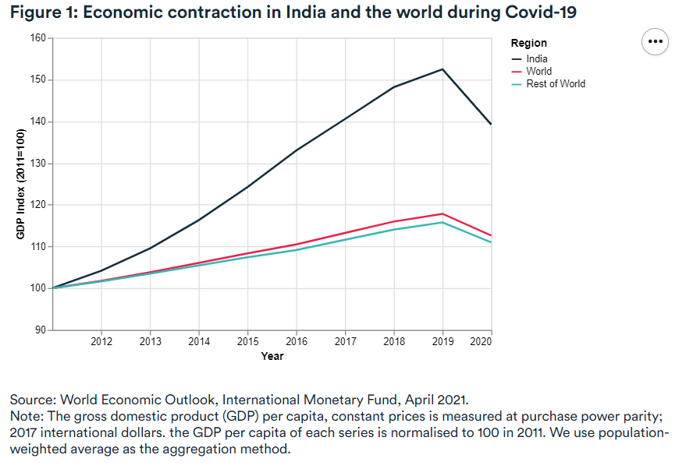

Through this project, we aim to make an analysis and have a thorough understanding of how the virus has impacted the economy and the effect it has had in the funding of startups.

1. **Literature Survey**

### The coronavirus (COVID-19) pandemic: Challenges among Iranian startups

The coronavirus outbreak has grown into a worldwide crisis with huge implications for capital markets and the global economy; its consequences are expected to be far worse than those of past global recessions. In the meantime, due to the pandemic's effects, startups are more likely to fail or thrive than ever before; yet, the obstacles they confront have yet to be thoroughly examined, as the epidemic moved quicker than researchers expected. As a result, by interviewing the co-founders of fifteen well-known firms, this research explores the primary problems faced by Iranian entrepreneurs. The data was evaluated using two-step coding, and the conclusions were discussed in a focus group including company co-founders, legislators, and academics. There are six major sorts of difficulties to be handled, encompassing financial, management of human resources, support legislation and procedures, marketing, crisis management, and others.

### IMPACT OF CORONA VIRUS COVID-19 ON THE GLOBAL ECONOMY

The impact of the COVID-19 epidemic on the global economy was the subject of this paper. The research looked at the corona virus outbreak and its effects on agriculture, energy, space science, and the general economy. The Coronavirus, which has dangerous, difficult, and bothersome economic repercussions, is expected to cause a rapid economic crisis, causing the world's predicted budget to burst in the first quarter. A trillion dollars in worldwide revenue is anticipated to be lost as a result of the global economic slowdown. Because of the pandemic's global expansion, webinars and conferences in technology, sports, and fashion have been postponed or canceled, as well as the closure of stores and businesses (excluding medicines and grocery), indicating a detrimental influence on the economy of the nations. It has had a wide range of effects on the agricultural industry, affecting farmer income and profit and also distributors and consumers. As a result, legislative action and advanced research laboratories are urgently needed so that the globe, with all of its key afflicted countries, can turn the situation around and bring economic development closer to the aim.

### CORONAVIRUS PANDEMIC AND ITS IMPLICATION ON GLOBAL ECONOMY

The COVID-19 pandemic, commonly known as coronavirus, is no longer just a health concern. Its effects are felt at all levels of society, with serious implications for social, economic, educational, political, and human security. The study's goal is to examine how COVID-19 has impacted the global economy and to identify some of the actions that may be taken to prevent the pandemic from spreading further. It was shown that the epidemic has had a significant negative impact on worldwide economic growth and development. As a result, the research suggests that palliative measures be implemented for everyone, as this will aid in minimizing the economic suffering caused by the epidemic. The study also gives the count of the covid cases then in different parts of the world. It describes the different aspects of the economy and how that has taken a hit as well and suggests measures to control COVID-19.

### The socio-economic implications of the coronavirus pandemic (COVID-19): A review

Over 4.3 million reported cases and 290,000 fatalities have been reported worldwide as a result of the COVID-19 pandemic. It has also generated concerns about an approaching economic downturn. Social isolation, self-isolation, and travel limitations have resulted in a diminished workforce in all economic sectors, resulting in the loss of employment. The demand for commodities and manufactured goods has declined as schools have closed. Medical supplies, on the other hand, have seen a major growth in demand. Due to panic buying and hoarding of food supplies, the food industry is also seeing increasing demand. They have summed up the socio-economic repercussions of COVID-19 on specific elements of the global economy in response to this worldwide pandemic. The impact on the primary, secondary and tertiary sectors and the responses by the different countries to each of the issues have also been explained.

### 

### The Coronavirus Economic Crisis: Its Impact on Venture Capital and High Growth Enterprises

This article is part of the European Commission's Joint Research Centre's (JRC) ongoing research on high-growth innovative businesses (HGEs) and scale-up companies, which is headed by the Unit for Finance, Innovation, and Growth (B7). This comprehensive project has looked at the sectoral and geographic heterogeneity of HGE demography in the EU, as well as the framework circumstances that impact their development, with a focus on financing and risk-financing in particular. The work is aimed to give both EU-wide and member-state specific input to the yearly cycle of economic policy coordination in the EU known as the "European Semester," in keeping with the JRC's function of providing evidence and analysis to back EU policy. It is undertaken in close interaction with a wide variety of Commission policy DGs. The vulnerability of high-growth and potential high-growth firms is a major worry in the context of the COVID-19 crisis and the governmental response to the immediate and eventual socio-economic impact, especially given the disproportionate role these enterprises may play in guaranteeing a long-term sustainable exit from the crisis.Because risk capital is so important to these companies, it's critical to have a near-real-time means of monitoring the crisis's effects on venture capital markets in Europe and around the world, so that relevant evidence can be provided in near-real time to those developing and implementing policy responses to the crisis. In this sense, this study is a particularly relevant addition.

## Feasibility Study

The analysis parameters for the COVID-19 analysis could be of any form. Here, we specifically study and build our model over our own dataset. Some of the following areas of motivation:

* The concern of COVID-19 in the world and a way to analyze and bring some data that can be made use of to work on approaching the pandemic better
* The interest to try and work on various algorithms and get something useful out of such experimentation.
* Interest in startups and business

The most feasible solution to go through the proper analysis is to try and use the different datasets for each of the values and maybe merge the data and remove overlapping ones from the other dataset. To consider the startups and their growth during this period. This study will cover only the datasets that have been taken with regard to unemployment and COVID-19 cases and startup funding. We intend to use some models to forecast and predict useful information and also visualize the data.

## About The Dataset

We have taken 5 datasets and an explanation of the survey methods is listed below.

1. [Dataset 1](https://data.oecd.org/unemp/unemployment-rate.htm) : A subset of the Main Economic Indicators (MEI) database, Labor market statistics includes labor force, unemployment level and rate, employment by industry and services. Data are collected from sample household surveys on a monthly or quarterly basis for OECD countries and non-member economies.
2. [Dataset 2:](https://unemploymentinindia.cmie.com/) The survey is planned and executed in a manner that enables the estimation of unemployment at a monthly frequency.The sample size of 43,600 household per month is well distributed over the country to enable the estimation of a monthly unemployment rate. The monthly sample is well-distributed over rural and urban regions to enable a weekly estimation of unemployment at the all-India level. About 10,900 households are surveyed every week. These yield a sample of about 35,900 individuals for the estimation of weekly unemployment.The rural sample comprises 63,430 households from 3,965 villages.
3. [Dataset 3:](https://data.mendeley.com/datasets/b2wvnbnpj9/1) 170 countries are utilized in this study, and econometric panel techniques such as OLS and robust least square regression methods are utilized. The data was collected from OurWorldindata.com, comprising total COVID-19 cases, total deaths, stringency index, human development index, and gross domestic product per capita. The study's findings stipulate that many people's stringency and the contraction of the disease have inversely affected poverty alleviation and economic growth.
4. [Dataset 4:](https://www.kaggle.com/c/kaggle-survey-2020) This year's report is based on a survey of 20,037 Kaggle practitioners from 171 different countries and territories around the world. If a country or territory received less than 50 respondents, Kaggle grouped them into a group named “Other” for anonymity.An invitation to participate in the survey was sent to the entire Kaggle community (anyone opted-in to the Kaggle Email List). The survey was also promoted on the Kaggle website and on the Kaggle Twitter channel.Live from 10/07/2020 to 10/30/2020.
5. [Dataset 5](https://www.kaggle.com/sudalairajkumar/indian-startup-funding) : The data has been collected and made publicly usable by Trak.in.

## 5. Design and flow of models

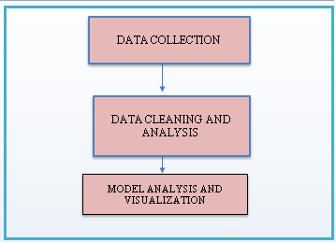

**Fig.1 design and flow of model**

for the analysis we have used the following modules and analysis parameters :

### Module 1 : Data Collection

We have utilized this time to go through research works of the time period on the two major covid waves. We collected the datasets related to our goals and the results we were looking for and after extensive research, we have obtained the datasets that we have chosen and decided to proceed on with our work in.

### **Module 2 :** D**ata** C**leaning and dataset analysis**

Now that we have the data , we will clean and preprocess the dataset. We remove the NaN records, drop unnecessary columns , then split compounded data fields to retrieve the data we need. We also rename a few columns and merge some of the datasets based on a common index that we had derived.

### M**odule 3 :** A**nalysis and visualization from dataset**

We have shown various visualizations of a contemporary period , i.e. the waves of covid and tried to show how it has affected them, be it unemployment rate ,global economy or startup funding.

#### Based on impact of lockdown on unemployment

The relation between covid and unemployment was plotted out on a interactive graph with a slider that controls the time hence being able to visualize the change in unemployment rates across different countries.

#### Based on other variables vs months or countries

The distribution of other variables like hdi , stringency , etc helps us get an understanding of the economic effect on covid on the countries.

#### Based on unemployment in rural vs urban areas

Since we were able to get the region-wise weekly unemployment data, we showed a comparative study on the distribution of unemployment rates.

* 1. based on start-up funding

**ARIMA Algorithm**

An autoregressive integrated moving average model is a type of regression analysis that determines how strong one dependent variable is in comparison to other changing variables. The purpose of the model is to anticipate future securities or financial market movements by looking at the discrepancies between values in a series rather than actual values.

ARIMA treats each component as a parameter with a consistent nomenclature. ARIMA with p, d, and q is a standard notation for ARIMA models, where integer values replace the parameters to denote the kind of ARIMA model utilised. The parameters are as follows:

p: the model's lag order; sometimes known as the number of lag observations.

d: the degree of differencing; also known as the number of times the raw observations are differed.

q is the size of the moving average window; it is also known as the moving average order.

**Multivariate Time Series Forecasting with LSTM**

In machine learning, time series forecasting is an important topic. It is, nevertheless, disregarded because of its complexity, which is due to time components such as trend, seasonality, base level of series, and noise. Time series forecasting is similar to other machine learning techniques in that it requires fitting models to past data and then utilizing the fit to predict future data. The only significant distinction between the simple prediction-based model and the forecasting model is that forecasting is not accessible in this case and must be approximated only on the basis of what has already occurred.

Long Short Term Memory networks – usually just called “LSTMs” – are a special kind of RNN, capable of learning long-term dependencies.LSTMs are explicitly designed to avoid the long-term dependency problem.LSTMs also have this chain like structure, but the repeating module has a different structure. Instead of having a single neural network layer, there are four, interacting in a very special way.

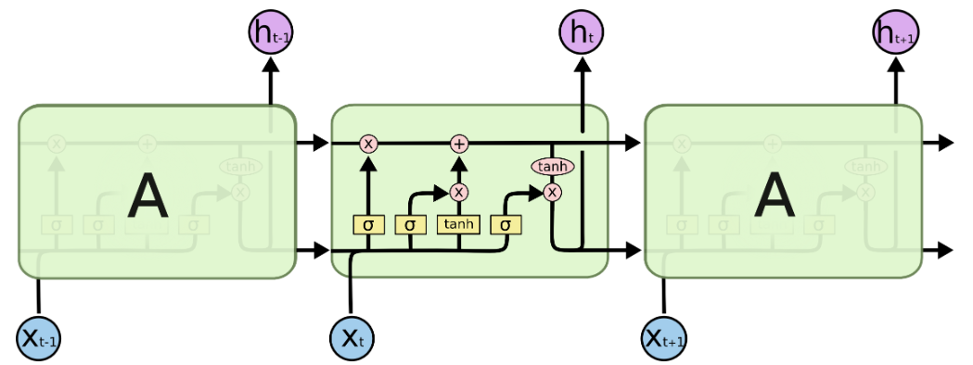

## 6. Risk Analysis:

Due to the vast amount of data online, it might be hard to find data that is authentic and not redundant. Hence, we have taken the data on COVID-19 from the official sites etc to give us the unemployment rate data, HDI, GDP and the number of cases and death tolls, start-up funding and so on, but this can affect our analysis for bias based on time the start-up was founded or based on when the data was collected for the cases and to the specific region etc. There can be several parameters which can affect the  bias created in the data. Some of few can be the time at which the data was collected, authenticity, start-up funding for companies that were initiated after the data was collected, companies that are covered only in a specific country and hence we restrict ourselves to several parameters for data analysis and visualization. We only intend to use some forecasting algorithms to predict and forecast the start-ups funding into the future.

## 7. IMPLEMENTATION

1. **First we import modules that we shall be using for our project**

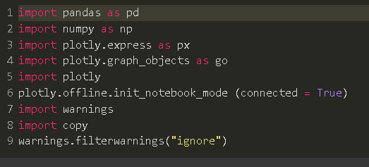

**Importing the libraries and modules**

First import the libraries to better analyze the data set.

1. **Dataset analysis**

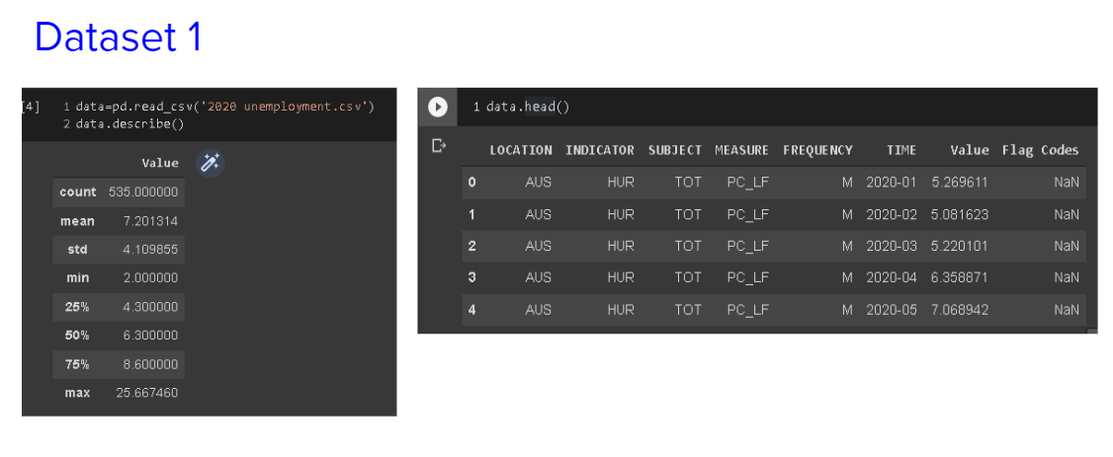

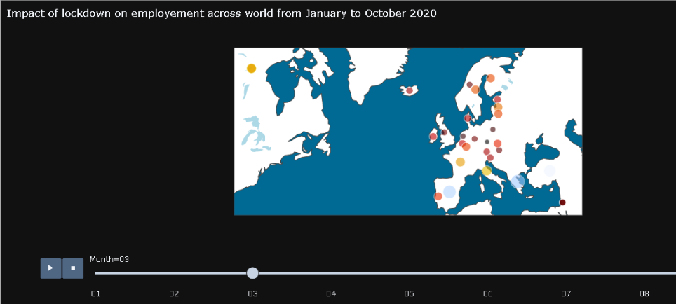

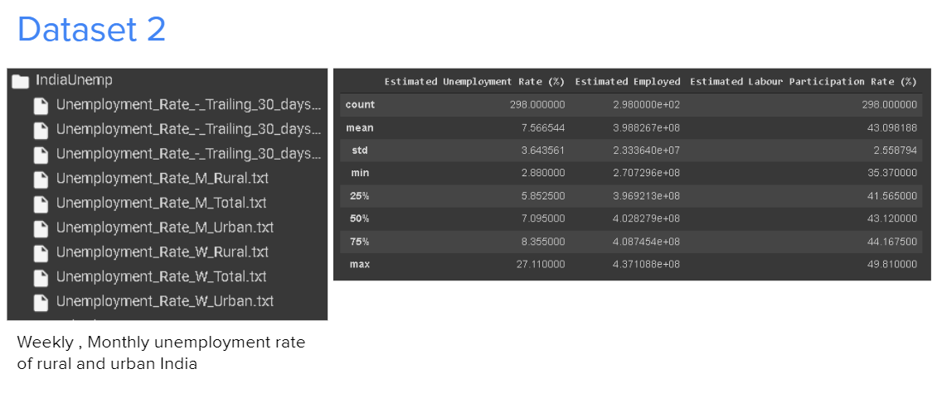

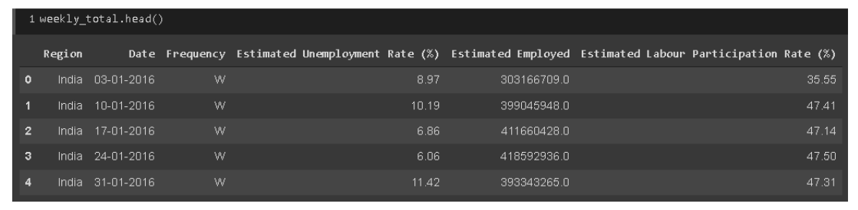

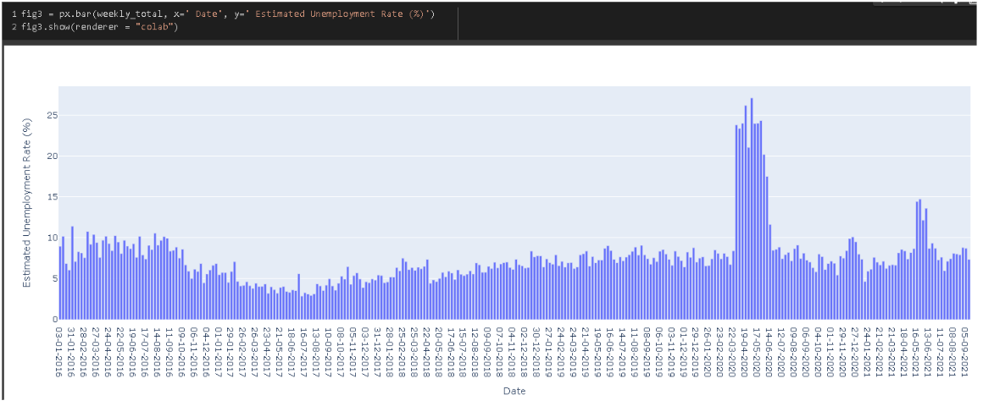

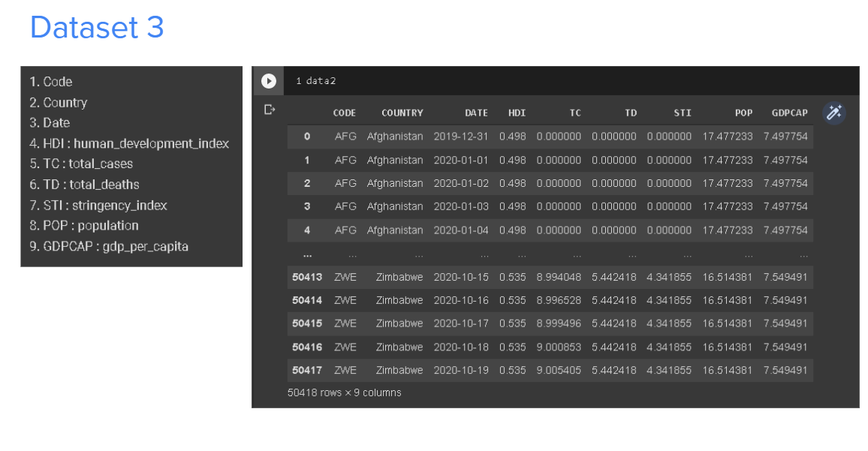

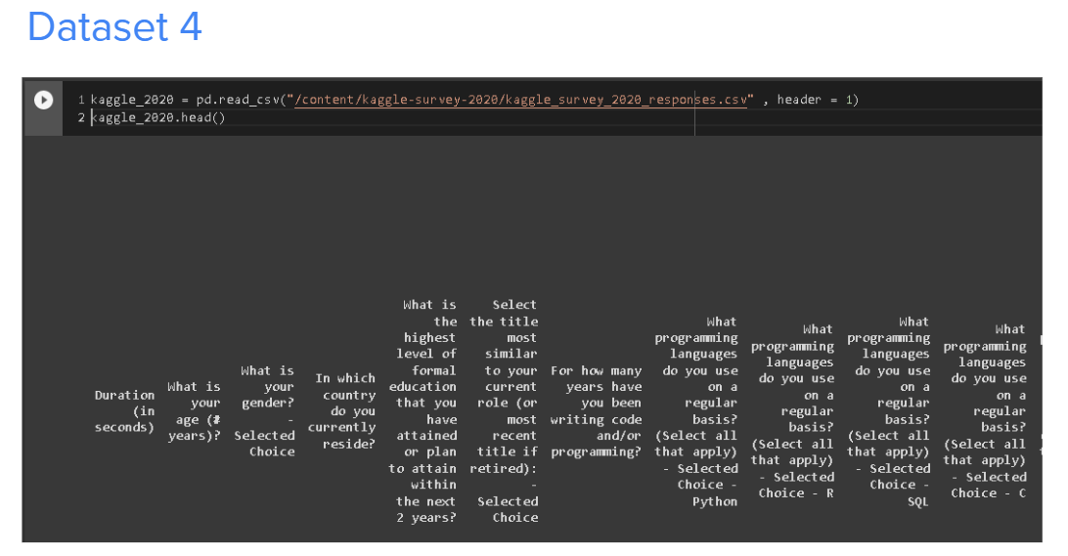

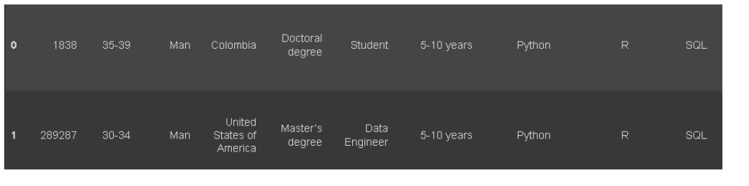

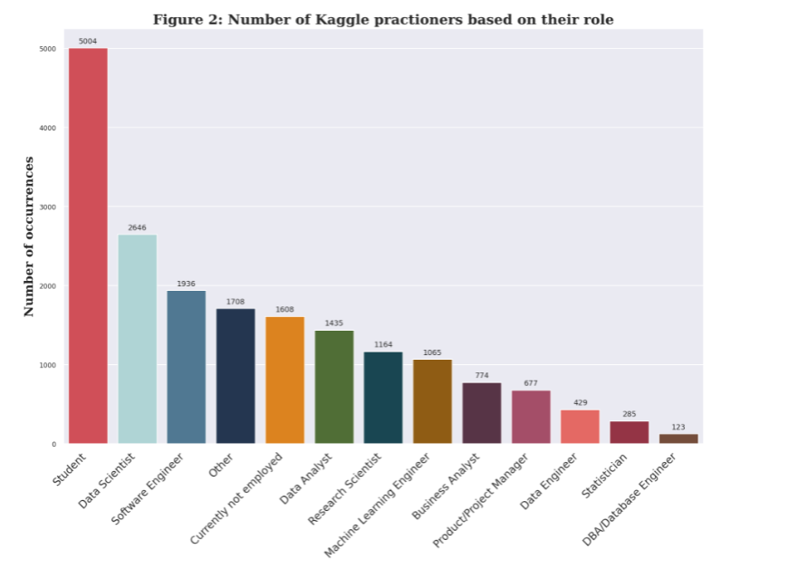

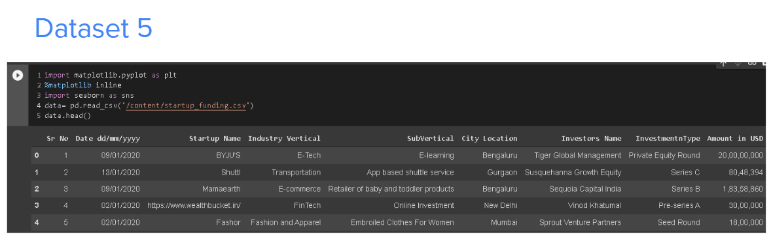

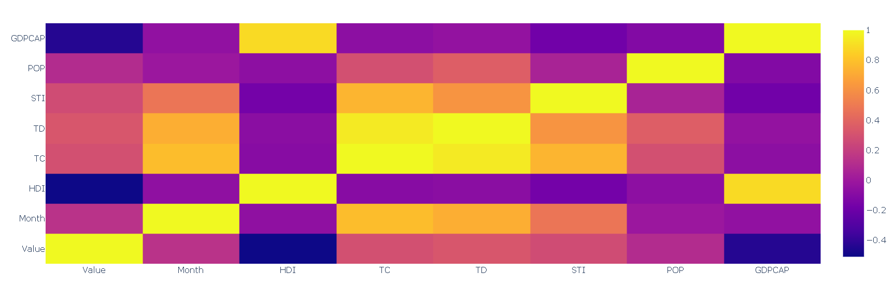

1. **Data Visualization**

Value vs Month

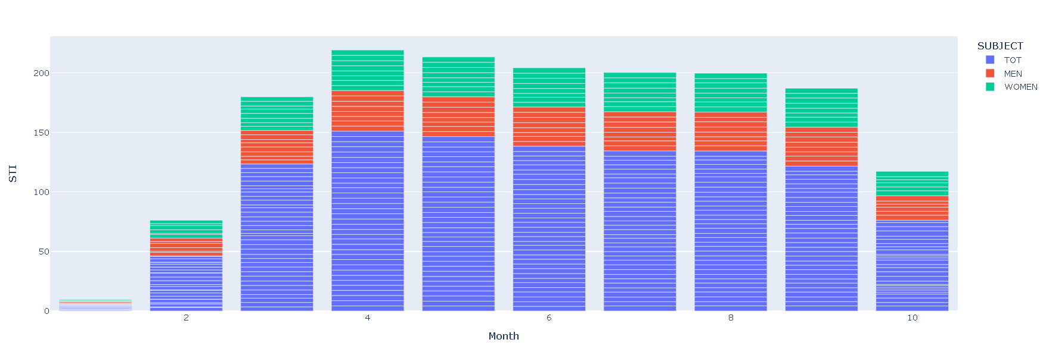

GCP CAP vs HDI colored by Country

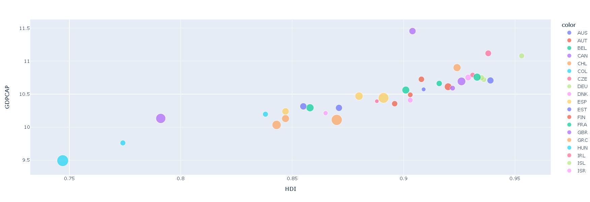

Weekly Unemployment by region type

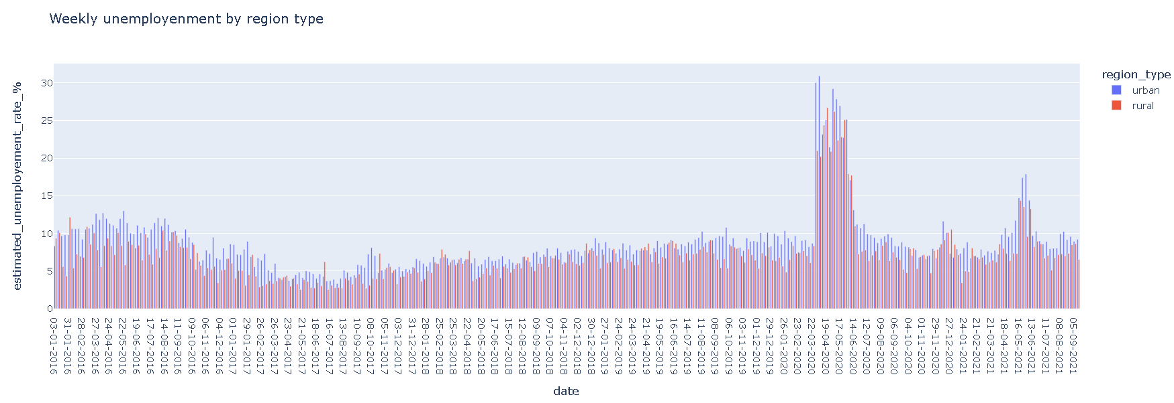

4 weeks avg unemployment rate by region type

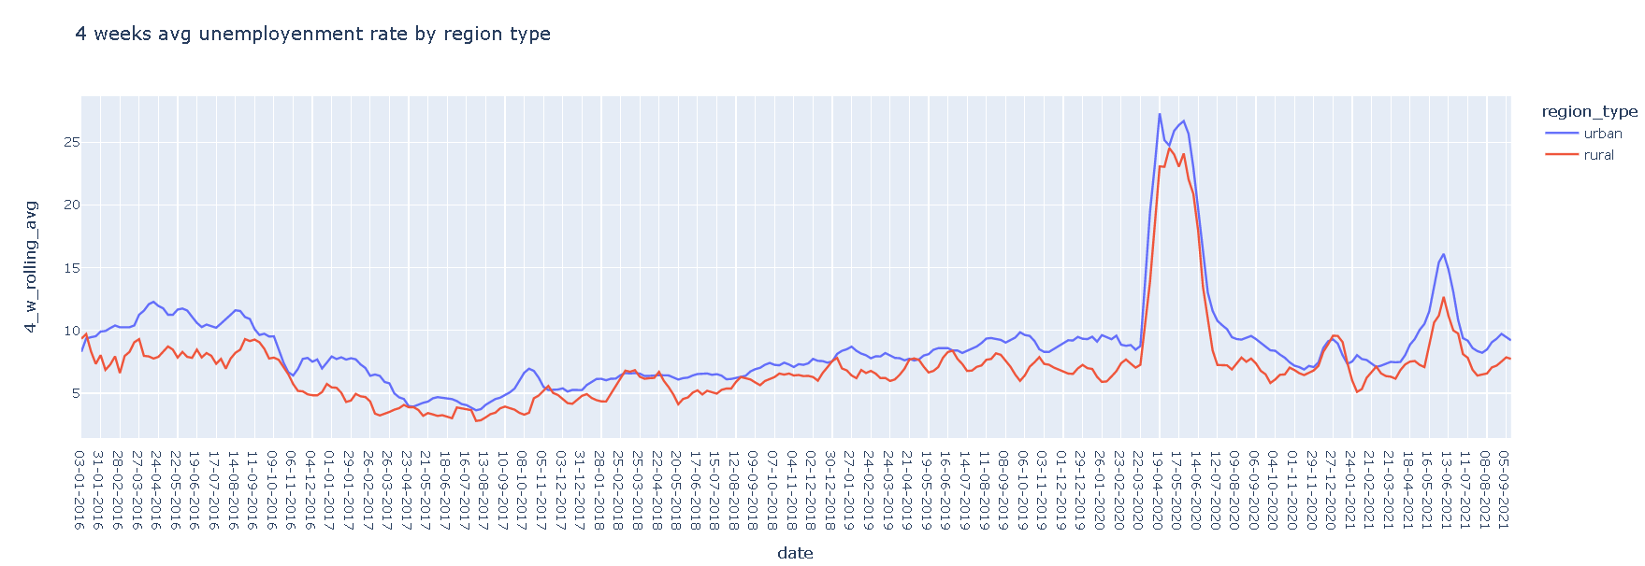

Start-up Funds Plotted

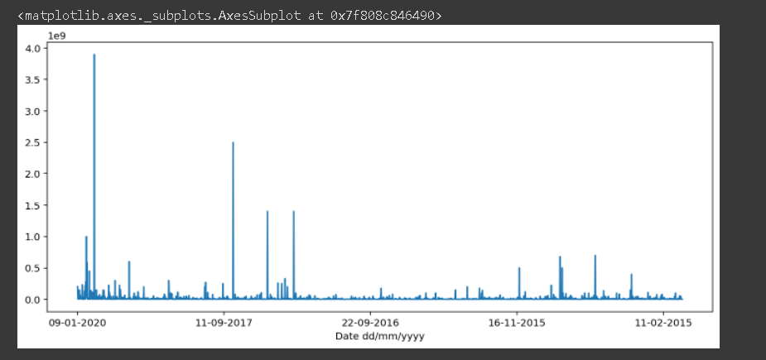

After deleting outliers

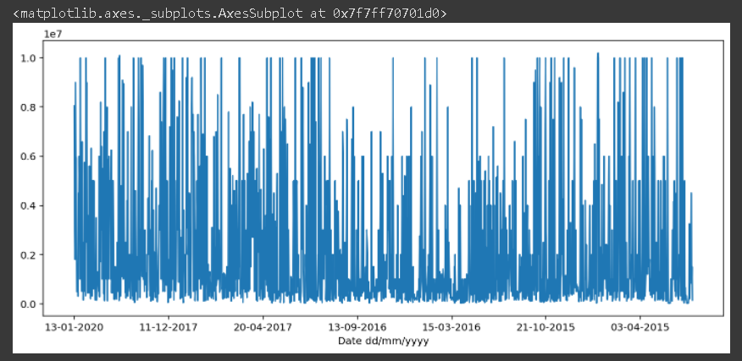

ARIMA MODEL

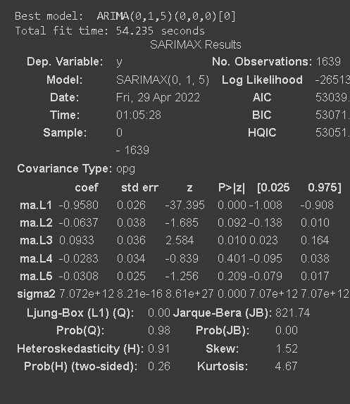

Predicted Mean

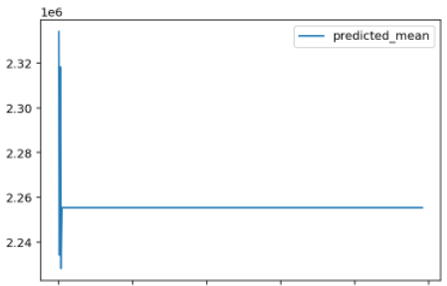

Plot of values on the merged unemployment and economy dataset

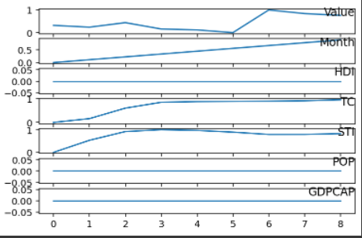

Featured Calculated

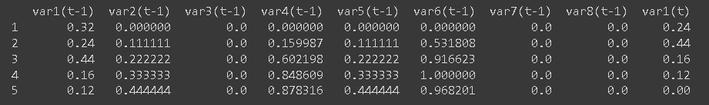

Lstm

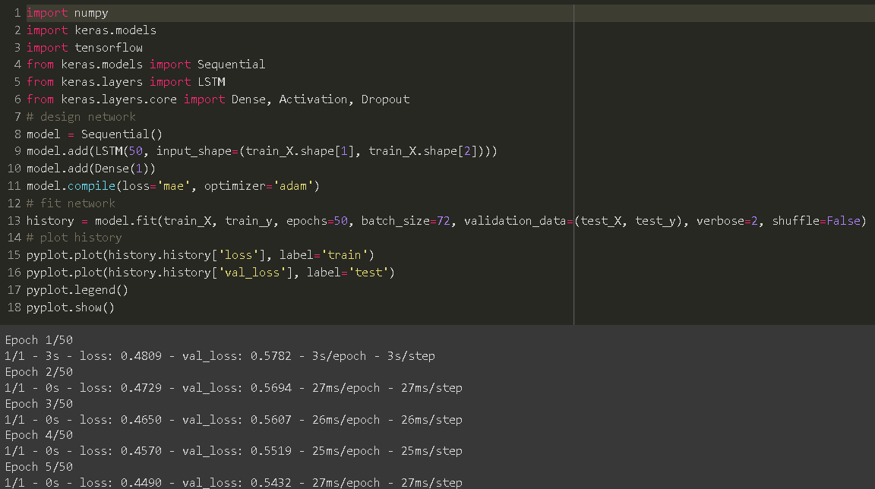

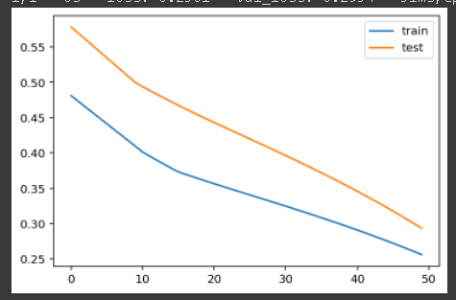

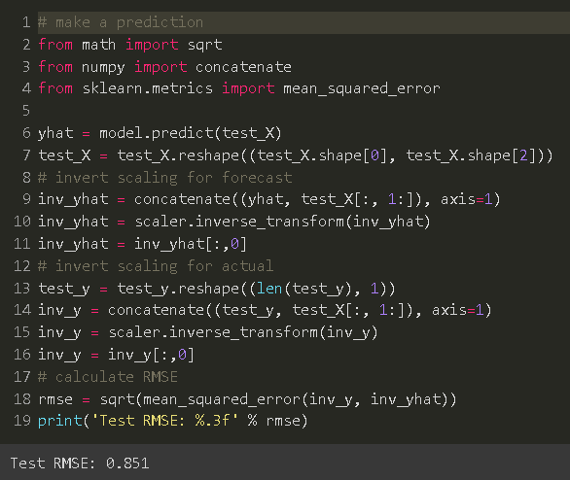

**Tableau**

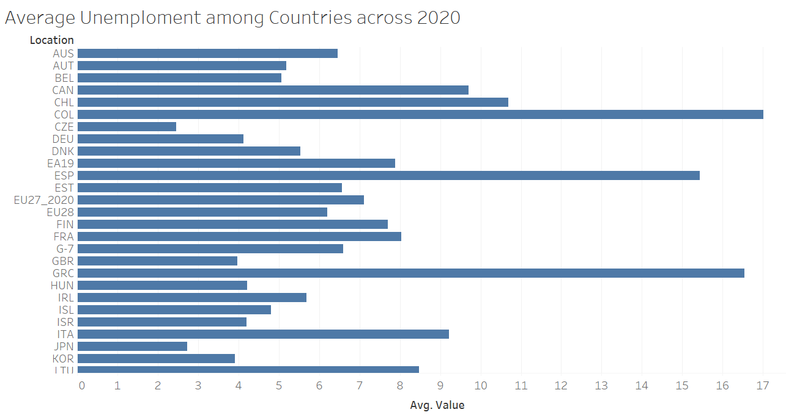

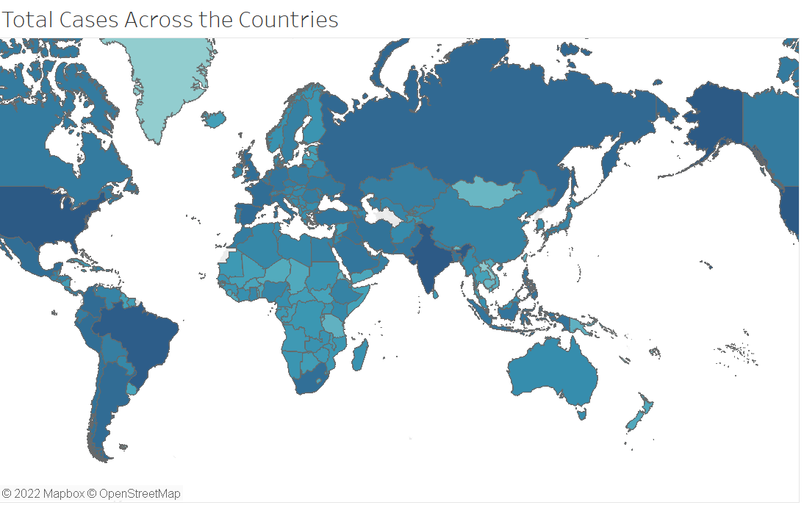

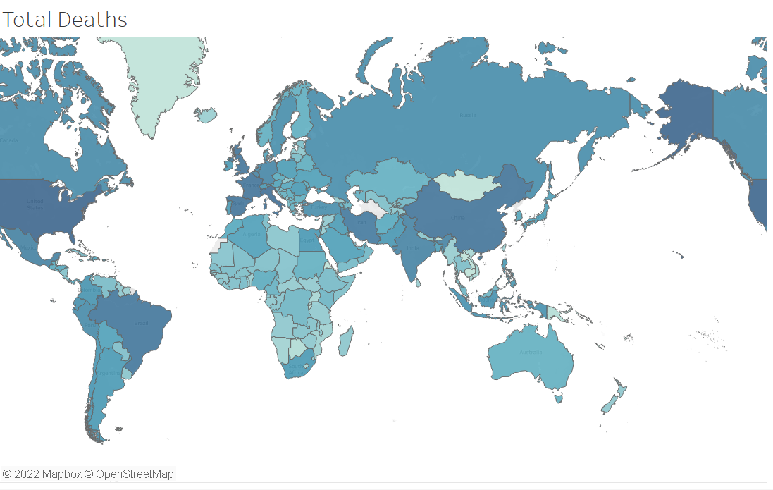

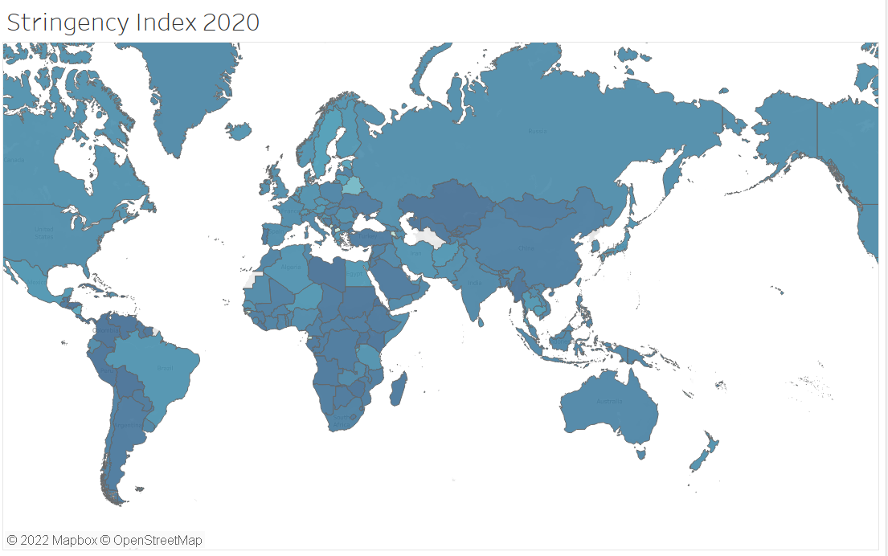

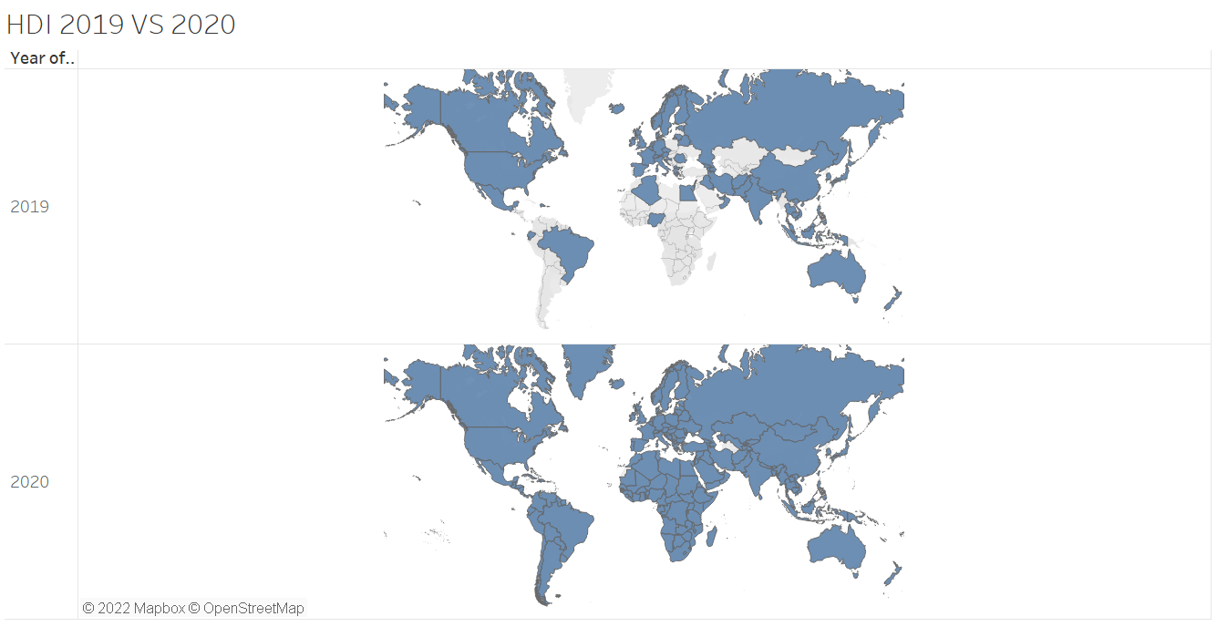

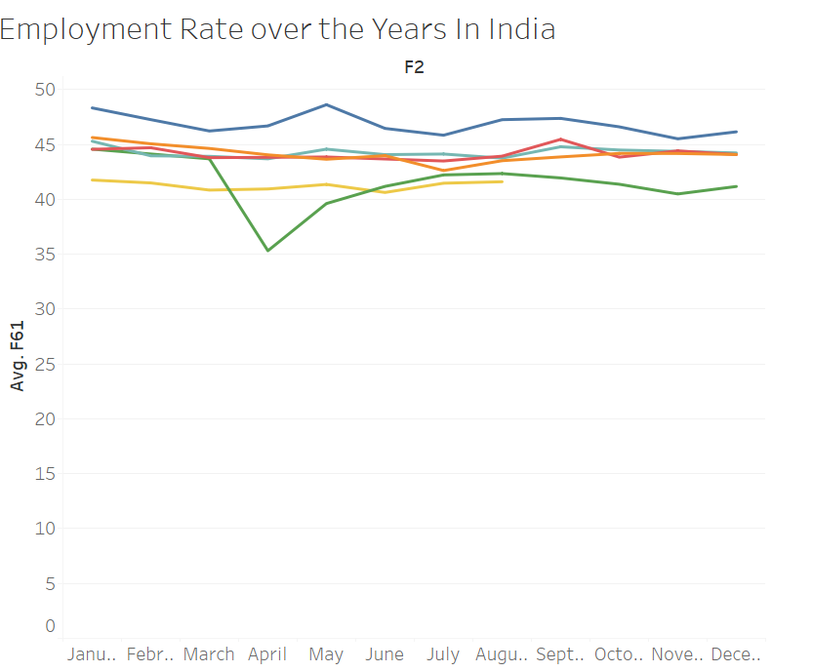

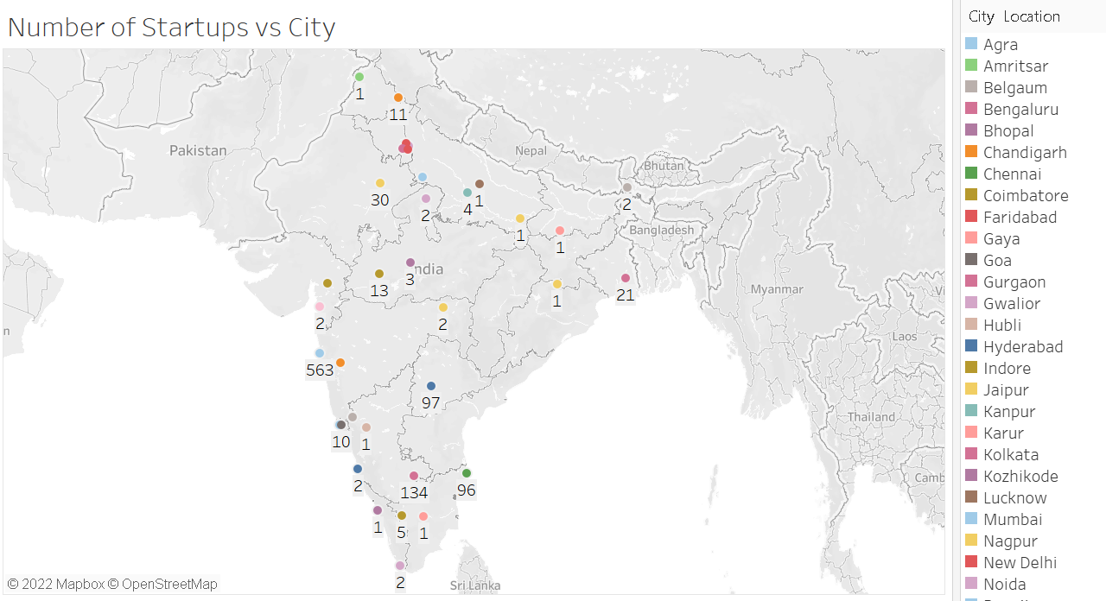

**CONCLUSION**

India has been hit hard by the pandemic, particularly during the second wave of the virus in the spring of 2021. The sharp drop in GDP is the largest in the country’s history, but this may still underestimate the economic damage experienced by the poorest households.

While economies worldwide have been hit hard, India has suffered one of the largest contractions. During the 2020/21 financial year, the rates of decline in GDP for the world were 3.3% and 2.2% for emerging market and developing economies. Table 1 summarizes macroeconomic indicators for India, along with a reference group of comparable countries and the world. The fact that India’s growth rate in 2019 was among the highest makes the drop due to Covid-19 even more noticeable.

Comparing national unemployment rates in 2020, India’s rate of 7.1% indicates that it has performed relatively poorly – both in terms of the world average and compared with a set of reference group economies with similar per capita incomes. Unemployment rates were more muted within the reference group economies and were also kept low by generous labor market policies to keep people in work.

Despite the scale of the pandemic, additional budgetary allocation to various social safety measures has been relatively low in India compared with other countries. Although the country might look comparable to the reference group in non-health sector measures, the additional health sector fiscal measures are less than half those in the reference group. More worryingly, the Indian government's announced allocation in the 2021 budget for such measures does not show an increase, once inflation is taken into account.

**REFERENCES:**

[1] Aidin Salamzadeh & Leo Paul Dana (2020): The coronavirus (COVID-19) pandemic: challenges among Iranian startups, Journal of Small Business & Entrepreneurship, DOI: 10.1080/08276331.2020.1821158

[2] Shruti Mohapatra, Priyanka V.,Swati Mohapatra, Isha Kohli and Raj KishoreMishra (2020). Impact ofCorona VirusCovid-19 on the Global Economy. International Journal of Agricultural and Statistical Sciences. DocID: https://connectjournals.com/ 03899.2020.16.771

[3] International Journal of Arts, Languages and Business Studies (IJALBS), Vol.4; March, 2020; pg. 13 - 23

[4] Maria Nicola, Zaid Alsafi, Catrin Sohrabi, Ahmed Kerwan, Ahmed Al-Jabir, Christos Iosifidis, Maliha Agha, Riaz Agha, The socio-economic implications of the coronavirus pandemic (COVID-19): A review, International Journal of Surgery, Volume 78, 2020,

Pages 185-193, ISSN 1743-9191, [https://doi.org/10.1016/j.ijsu.2020.04.01](https://doi.org/10.1016/j.ijsu.2020.04.018)8

[5] Mason, Colin. *The coronavirus economic crisis: Its impact on venture capital and high growth enterprises*. Publications Office of the European Union, 2020.

[6] Koshle, Himanshu, Rabab Kaur, and Ruchi Basista. "Breakdown of business and workers in India: impact of corona virus." *Available at SSRN 3557544* (2020).

[7] da Camara, Rafael, et al. "How do Agile Software Startups deal with uncertainties by Covid-19 pandemic?." *arXiv preprint arXiv:2006.13715* (2020).

[8] Carlsson-Szlezak, Philipp, Martin Reeves, and Paul Swartz. "What coronavirus could mean for the global economy." *Harvard Business Review* 3.10 (2020): 1-10.

[9] Fernandes, Nuno. "Economic effects of coronavirus outbreak (COVID-19) on the world economy." (2020).

[10] Hoque, Ashikul, et al. "The effect of Coronavirus (COVID-19) in the tourism industry in China." *Asian Journal of Multidisciplinary Studies* 3.1 (2020): 52-58.

Text Box 1